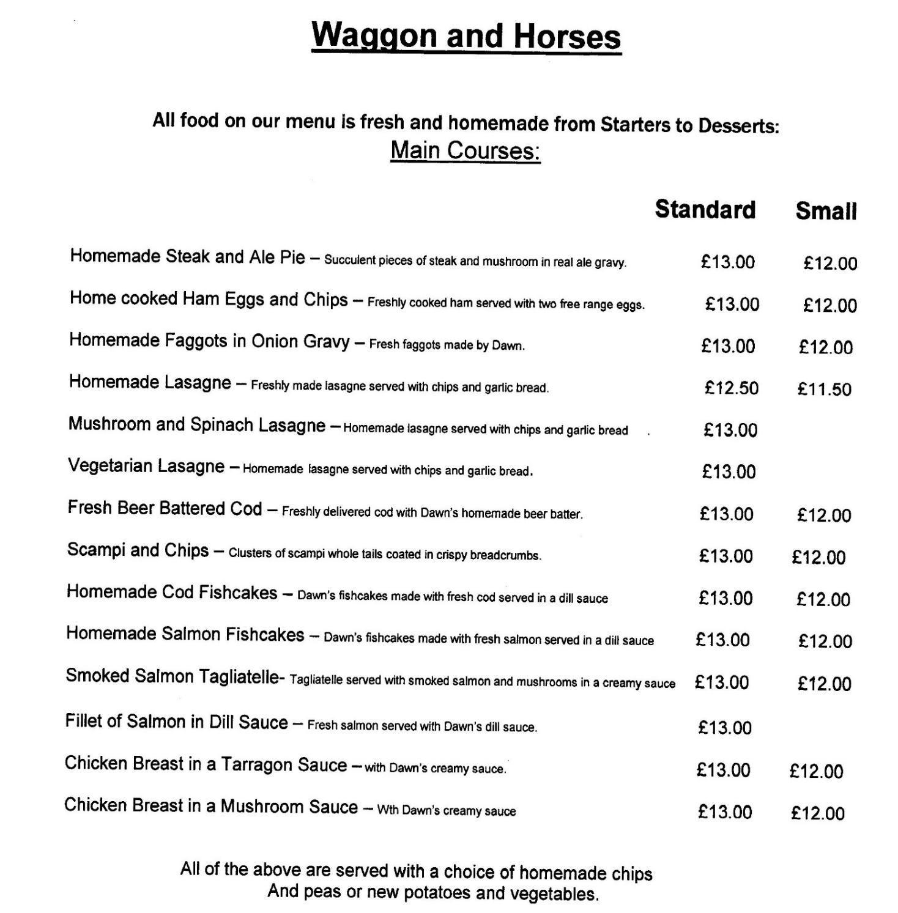
In addition to the above, the pub can do the following Main Courses
A Curry of the day/Venison Faggots/Liver & Bacon/Beer Battered Haddock.

Please Note:
By 7th May the pub may have to increase the above prices by 50p to £1.00 to cover the increase in raw materials and staff costs

